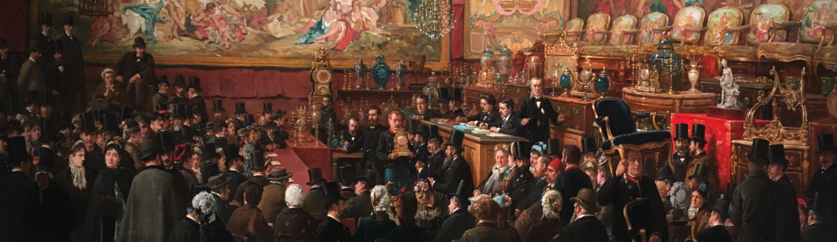
An Auction at the Hotel Drouot 1876, Private collection, courtesy of Talabardon & Gautier, Paris

Academic Conference and Workshop
on
The Formation and Development of New Markets

TOOLS FOR THE FUTURE: RESEARCHING ART MARKET PRACTICES FROM PAST TO PRESENT
Thursday 30 May, Royal Academy
Friday 31 May, Kingston School of Art, Kingston University
As the art market has grown and evolved worldwide, there have been many instances where new areas of production, trade, collecting and valuation of art have emerged. This academic conference and workshop focuses on exploring new paradigms and ways that art markets function, whether in the primary or secondary sector. The aim of this two-day conference and workshop is to evaluate, analyse and explore the range of mechanisms by which a particular ‘product’ enters the art market, how these markets evolve and who are the key players whether collectors or dealers,) individuals or institutions as well as the range of other agents. Well document prior areas of research into art market innovation, emergence and growth include17th century imports of Chinese and Japanese ceramics, lacquers and textiles; the market for 17th century Dutch and Flemish paintings in Paris and London during the 18th century; and the rise of the Barbizon school in 19th-century Paris. More recently we have seen the emergence of photography and street art as important areas of production introducing both opportunities and risks to existing and new players. New art forms such as digital and video art raise further questions as to whether existing models of agency are still appropriate and thus, whether new technology is fundamentally changing the creation, trade, consumption and validation of art.
This conference invites new and existing research around the emergence of art markets, their evolution and dynamics. Conference topics will include: the role of the state in the development of markets, the role of the artist. The art fair and the collector the creation of new markets, the dealer and the market, mapping markets, the role o f new media and impact of social change – with an ongoing focus and discussion on the tools, techniques, research methods and strategies which enable the study of art markets.
In-depth discussion following each group of papers will allow participants to explore the complex relationships between the different factors that create, support and sustain the rise or fall of particular markets. The workshop ends with two round table discussions to explore further the methodologies involved in researching new markets.
For further information or to register please email adrianaturpin@gmail.com

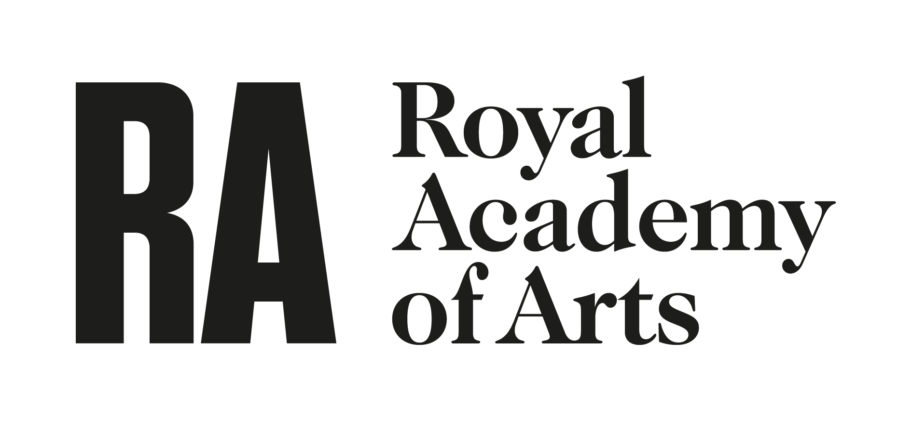
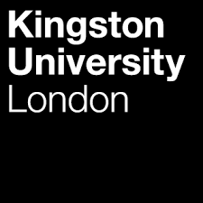

Programme
Thursday, 30 May, Royal Academy
9.45 Welcome : Dr, Anna Dempster, Head of Academic Programmes at the Royal Academy of Arts
9.50 Introduction: Adriana Turpin, Institut d’Études Superièures des Arts
10.00 Keynote: Bénédicte Miyamoto, Université Sorbonne Nouvelle: New market testing old networks at London auction houses, 1760-1815
10.50 Coffee Break
11.20 SESSION ONE: The role of the state
Chair: Anna Dempster
Renata Komić Marn, Tina Košak, ZRC SAZU, France Stele Institute of Art History, Ljubljana: Caught between New Politics and Economic Crisis: Market with Art and Antiquities in Interwar Yugoslavia
Hoe Su Fern, Singapore Management University; Lively Infrastructures: Tracing the Redistributive Potentials of the State-Led Development of a Contemporary Art Marketplace in Singapore
Malvika Maheshwari, Ashoka University, Sonipat: The State of the Arts: Role of the Indian State in Making Artists and the ‘Emerging Indian Art Market’
DISCUSSION
12.30 LUNCH
13.30 SESSION TWO: Artists and the fair creating new markets
Chair: Adriana Turpin
Sarah Bakkalli, University of Paris X Nanterre, From the artist studio to the amateur's portfolio: the modern drawing market and collecting in Paris early 19th
Marta Pérez Ibáñez, University of Granada, The 21st Century Self-managing Artist and the genesis of new art market trends in Spain
Michele Casagrande, Erasmus University, Rotterdam, Spreading the word. The Venice Biennale as “globalisation gateway” and its impact on the international diffusion of People’s Republic of China contemporary art.
Anna Pojer, Royal Academy Creating a market for Street Art
DISCUSSION
15.00 BREAK
15.30 SESSION THREE: The Collectors role in creating new markets
Chair: Anna Dempster
Tamara J. Mason, Temple University, El Greco and the Barnes Foundation: A “Proto-Modernist” in the burgeoning American art market
Ludmila Budrina, Ural Federal University, The Demidoffs and the creation of a market for malachite
Leslie Ramos, University of Cambridge, The Latin American Art Market: potential growth in an evolving yet fragile socio-economic environment
DISCUSSION
16.45 SESSION FOUR The Dealer in the Market
Chair: Nathalie Moureau
Ludewijk Dekker and Ellen Loots, Erasmus University, Rotterdam, Does art follow money, or money follow art? A qualitative study of the emerging art market in the city of Rotterdam
Alice Ensabella, University of Grenoble , Alphonse Bellier and the creation of the market of modern art at the Hotel Drouot (Paris, 1920-1930)
Olga Kanzaki Sooudi, University of Amsterdam, A dealer’s work: Creating value in an emerging art market
DISCUSSION
18.00 Close of day & wine reception

FRIDAY, 31 May, School of the Arts Kingston University
10.15 WELCOME & INTRODUCTION
10.20 Keynote: Léa St. Raymond, Université Paris Nanterre, The Launch of new artistic markets at Parisian auction houses, 1830-1939.
11. 00 COFFEE
11.30 SESSION FIVE: Mapping Markets
Chair: Elisabetta Lazarro
Nadine Oberste-Hetbleck, University of Cologne: A Digital Mapping Project on ART COLOGNE (1967–1997)
David Hinojosa Admann, artist and independent scholar, The Pure Taste Indicator - A new reference model for the art world
Erin Chang & Ellen Loots, Erasmus University, Rotterdam: How do performance goals of galleries relate to art market development? Evidence from the U.S. and the Netherlands
Discussion
12.45 SESSION SIX: New Media and Social changes
Chair: Nathalie Moureau
Kinga Hamvai, Moholy-Nagy University of Art and Design Budapest: Art in emerging markets: the case of India
Marcela Rusink, Masaryk University Brno, The art market as a sign of social change? Auctioning confiscated art in the Post-war Czechoslovakia
DISCUSSION
13.30-14.30 LUNCH
14.30-15.45 ROUND TABLE DISCUSSION: Dealers’ strategies
Chair: Mark Westgarth, University of Leeds, Lassla, Olga, Benedicte,
15.45 BREAK
16.15 17.30 ROUND TABLE: Developing tools for researching networks and data analysis
Chair: Léa St. Raymond, Université Paris Nanterre, Ellen Loots, Nathalie, Elisabetta
17.30-17.45 CLOSING REMARKS
Elisabetta Lazzaro, HKU University of the Arts, Utrecht, Natalie Moureau, Université Paul Valéry Montpellier 3
17.45 Wine Recepion
The conference is organised by Adriana Turpin (Institut d’Études Supérières des Arts, Paris), Elisabetta Lazzaro (HKU University of the Arts, Utrecht), Natalie Moureau (Université Paul Valéry Montpellier 3)) in partnership with Academic Programmes, Royal Academy of Art and Kingston School of Art, University of Kingston. It is further supported by the Society for the History of Collecting.

